Exercise 1: Logging Error Messages and Warning Levels

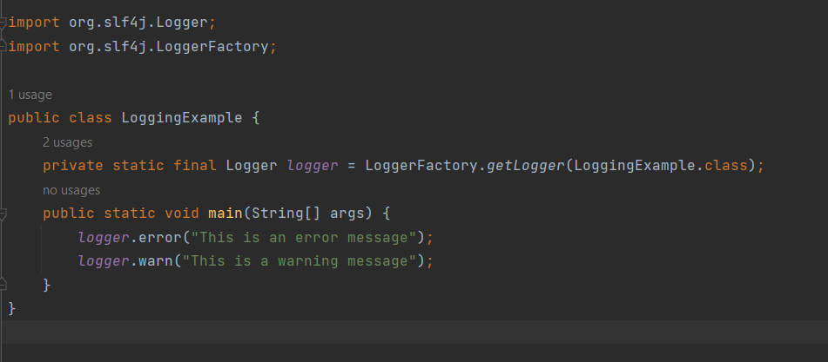

Output:

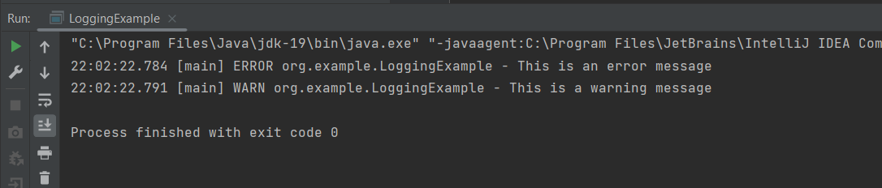

Exercise 2: Parameterized Logging

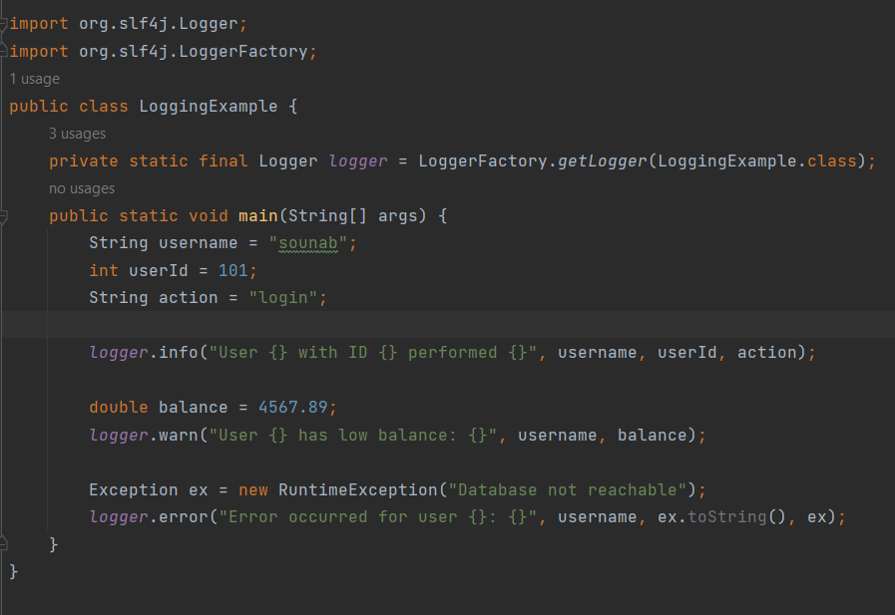

Output:

